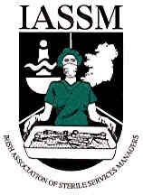

Irish Association of Sterile Services Managers (I.A.S.S.M.)

Membership Application Form

DATE: ____________________________________________________________

NAME: ____________________________________________________________

ADDRESS (WORK): ________________________________________________________________________

E-MAIL:______________________________________________________________

TELEPHONE:___________________________ FAX:__________________________

POSITION:___________________________DEPARTMENT:___________________

ADDRESS FOR CORRESPONDENCE:_____________________________________

FULL MEMBERSHIP (€30): □
ASSOCIATE MEMBERSHIP (€15): □

PLEASE RETURN APPLICATION FORM TO:
CAROLINE CONNEELY, C.S.S.D., CHILRENS UNIVERSITY HOSPITAL TEMPLE STREET DUBLIN 1, IRELAND. TEL: +353-1-8784252.

OFFICIAL USE ONLY

MEMBERSHIP APPROVED: YES NO

APPROVAL DATE: _______________________________

APPROVED BY:_______________________________________

